gcloud compute disks resize section-2-lab-handsondisk-ii \
--size=30GB \
--zone=us-central1-b

This command increases disk size. This change is not reversible.
For more information, see:
https://cloud.google.com/sdk/gcloud/reference/compute/disks/resize

Do you want to continue (Y/n)? y

Updated [https://www.googleapis.com/compute/v1/projects/training-416401/zones/us-central1-b/disks/section-2-lab-handsondisk-ii].
---
architecture: X86_64
creationTimestamp: '2026-04-30T12:22:42.422-07:00'
enableConfidentialCompute: false
guestOsFeatures:
- type: UEFI_COMPATIBLE
- type: VIRTIO_SCSI_MULTIQUEUE
- type: SEV_CAPABLE
- type: SEV_SNP_CAPABLE
- type: SEV_LIVE_MIGRATABLE
- type: SEV_LIVE_MIGRATABLE_V2
- type: GVNIC
- type: IDPF
- type: TDX_CAPABLE
id: '756779618658030317'
kind: compute#disk
labelFingerprint: 42WmSpB8rSM=
lastAttachTimestamp: '2026-04-30T12:22:42.954-07:00'
licenseCodes:
- '648289431948704420'
licenses:
- https://www.googleapis.com/compute/v1/projects/centos-cloud/global/licenses/centos-stream-10
name: section-2-lab-handsondisk-ii
physicalBlockSizeBytes: '4096'
satisfiesPzi: false
selfLink: https://www.googleapis.com/compute/v1/projects/training-416401/zones/us-central1-b/disks/section-2-lab-handsondisk-ii
sizeGb: '30'
sourceImage: https://www.googleapis.com/compute/v1/projects/centos-cloud/global/images/centos-stream-10-v20260428
sourceImageId: '7605354926341667847'
status: READY
type: https://www.googleapis.com/compute/v1/projects/training-416401/zones/us-central1-b/diskTypes/pd-standard
users:
- https://www.googleapis.com/compute/v1/projects/training-416401/zones/us-central1-b/instances/section-2-lab-handsondisk-ii
zone: https://www.googleapis.com/compute/v1/projects/training-416401/zones/us-central1-b

marvi@megamachine MINGW64 ~/Desktop/class-7.5-tko-group-homework/homework-01/deliverables/terraform_book_work (marvin-ev)
$
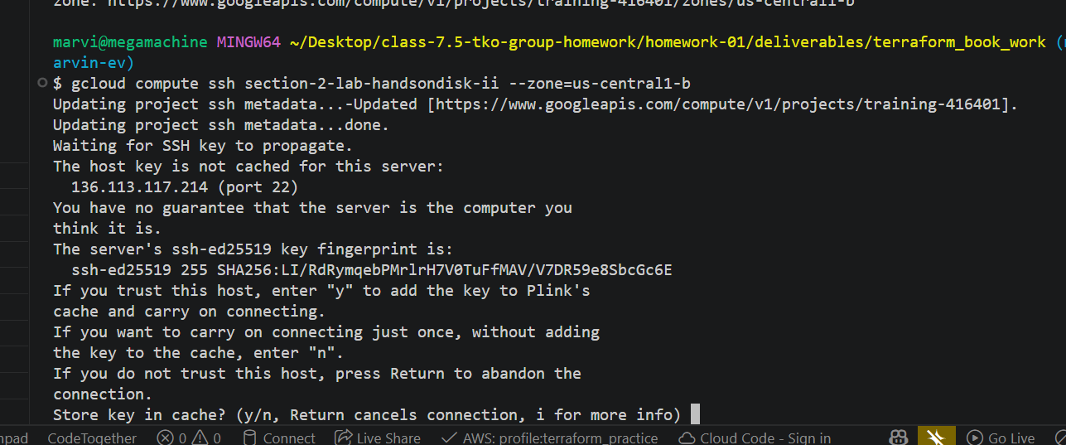
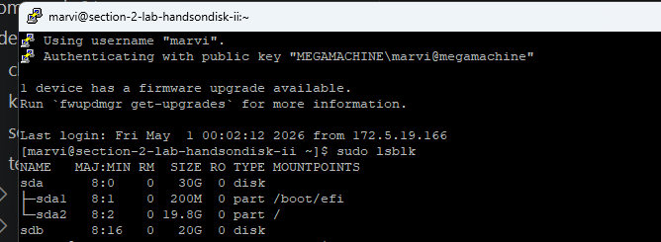

[marvi@section-2-lab-handsondisk-ii ~]$ sudo apt update
sudo apt install -y cloud-guest-utils
sudo: apt: command not found
sudo: apt: command not found
[marvi@section-2-lab-handsondisk-ii ~]$ sudo dnf install -y cloud-utils-growpart
sudo growpart /dev/sda 2
sudo xfs_growfs -d /
df -h
Last metadata expiration check: 3:23:00 ago on Thu 30 Apr 2026 10:56:21 PM UTC.
Dependencies resolved.
======================================================================================================
Package Architecture Version Repository Size
======================================================================================================
Installing:
cloud-utils-growpart noarch 0.33-11.el10 appstream 35 k
Installing dependencies:
device-mapper-event x86_64 10:1.02.210-2.el10 baseos 36 k
device-mapper-event-libs x86_64 10:1.02.210-2.el10 baseos 31 k
device-mapper-persistent-data x86_64 1.3.0-1.el10 baseos 1.2 M
libaio x86_64 0.3.111-22.el10 baseos 25 k
lvm2-libs x86_64 10:2.03.36-2.el10 baseos 1.0 M
Installing weak dependencies:
lvm2 x86_64 10:2.03.36-2.el10 baseos 1.6 M

Transaction Summary
======================================================================================================
Install 7 Packages

Total download size: 4.0 M
Installed size: 9.9 M
Downloading Packages:
(1/7): device-mapper-event-libs-1.02.210-2.el10.x86_64.rpm 131 kB/s | 31 kB 00:00
(2/7): device-mapper-event-1.02.210-2.el10.x86_64.rpm 147 kB/s | 36 kB 00:00
(3/7): libaio-0.3.111-22.el10.x86_64.rpm 277 kB/s | 25 kB 00:00
(4/7): device-mapper-persistent-data-1.3.0-1.el10.x86_64.rpm 2.2 MB/s | 1.2 MB 00:00
(5/7): lvm2-2.03.36-2.el10.x86_64.rpm 4.2 MB/s | 1.6 MB 00:00
(6/7): cloud-utils-growpart-0.33-11.el10.noarch.rpm 408 kB/s | 35 kB 00:00
(7/7): lvm2-libs-2.03.36-2.el10.x86_64.rpm 3.0 MB/s | 1.0 MB 00:00
------------------------------------------------------------------------------------------------------
Total 3.9 MB/s | 4.0 MB 00:01
Running transaction check
Transaction check succeeded.
Running transaction test
Transaction test succeeded.
Running transaction
Preparing : 1/1
Installing : device-mapper-event-libs-10:1.02.210-2.el10.x86_64 1/7
Installing : libaio-0.3.111-22.el10.x86_64 2/7
Installing : device-mapper-event-10:1.02.210-2.el10.x86_64 3/7
Running scriptlet: device-mapper-event-10:1.02.210-2.el10.x86_64 3/7
Created symlink '/etc/systemd/system/sockets.target.wants/dm-event.socket' → '/usr/lib/systemd/system/ dm-event.socket'.

Installing : lvm2-libs-10:2.03.36-2.el10.x86_64 4/7
Installing : device-mapper-persistent-data-1.3.0-1.el10.x86_64 5/7
Installing : lvm2-10:2.03.36-2.el10.x86_64 6/7
Running scriptlet: lvm2-10:2.03.36-2.el10.x86_64 6/7
Created symlink '/etc/systemd/system/sysinit.target.wants/lvm2-monitor.service' → '/usr/lib/systemd/sy stem/lvm2-monitor.service'.
Created symlink '/etc/systemd/system/sysinit.target.wants/lvm2-lvmpolld.socket' → '/usr/lib/systemd/sy stem/lvm2-lvmpolld.socket'.

Installing : cloud-utils-growpart-0.33-11.el10.noarch 7/7
Running scriptlet: cloud-utils-growpart-0.33-11.el10.noarch 7/7

Installed:
cloud-utils-growpart-0.33-11.el10.noarch
device-mapper-event-10:1.02.210-2.el10.x86_64
device-mapper-event-libs-10:1.02.210-2.el10.x86_64
device-mapper-persistent-data-1.3.0-1.el10.x86_64
libaio-0.3.111-22.el10.x86_64
lvm2-10:2.03.36-2.el10.x86_64
lvm2-libs-10:2.03.36-2.el10.x86_64

Complete!
CHANGED: partition=2 start=411648 old: size=41529344 end=41940991 new: size=62502879 end=62914526
meta-data=/dev/sda2 isize=512 agcount=4, agsize=1297792 blks
= sectsz=4096 attr=2, projid32bit=1
= crc=1 finobt=1, sparse=1, rmapbt=1
= reflink=1 bigtime=1 inobtcount=1 nrext64=1
= exchange=0 metadir=0
data = bsize=4096 blocks=5191168, imaxpct=25
= sunit=0 swidth=0 blks
naming =version 2 bsize=4096 ascii-ci=0, ftype=1, parent=0
log =internal log bsize=4096 blocks=16384, version=2
= sectsz=4096 sunit=1 blks, lazy-count=1
realtime =none extsz=4096 blocks=0, rtextents=0
= rgcount=0 rgsize=0 extents
= zoned=0 start=0 reserved=0
data blocks changed from 5191168 to 7812859
Filesystem Size Used Avail Use% Mounted on
/dev/sda2 30G 3.4G 27G 12% /
devtmpfs 1.8G 0 1.8G 0% /dev
tmpfs 1.8G 0 1.8G 0% /dev/shm
efivarfs 256K 26K 226K 11% /sys/firmware/efi/efivars
tmpfs 731M 8.6M 722M 2% /run
tmpfs 1.0M 0 1.0M 0% /run/credentials/systemd-journald.service
/dev/sda1 200M 8.6M 192M 5% /boot/efi
tmpfs 1.0M 0 1.0M 0% /run/credentials/getty@tty1.service
tmpfs 1.0M 0 1.0M 0% /run/credentials/serial-getty@ttyS0.service
tmpfs 365M 4.0K 365M 1% /run/user/1001

I resized the VM’s boot disk from 20GB to 30GB using the gcloud CLI. After resizing the disk at the cloud level, the operating system still reflected the old partition size. I installed the appropriate tools using dnf, then used growpart to expand the root partition (/dev/sda2), followed by xfs_growfs to expand the filesystem. Finally, I verified the change using df -h, which confirmed that the root filesystem now has 30GB available.

